**Graph Paper Programming**

**Group members:**

**Kenneth Bentley**

**Xiaona Zhou**

**Tamzid Chowdhury**

**Vitoria Tai**

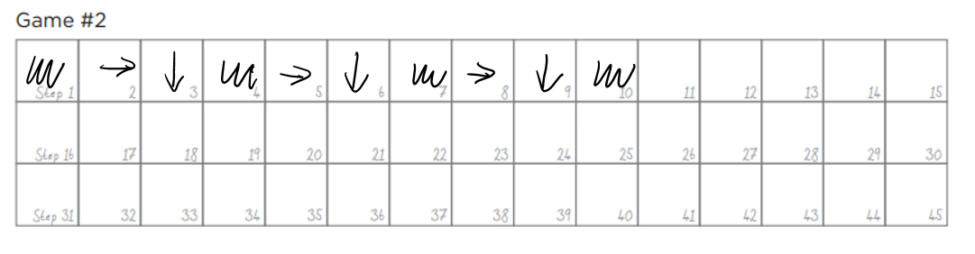

Method 2 (using function)

def rdc():

go right, go down, and color

|  |  |  |  |  |
| --- | --- | --- | --- | --- |
| color | rdc | rdc | rdc |  |

Xiaona Zhou: Method 1 (without using function)

Tamzid Chowdhury

|  |  |  |  |
| --- | --- | --- | --- |
|  |  |  |  |
|  |  |  |  |
|  |  |  |  |
|  |  |  |  |

Ken B

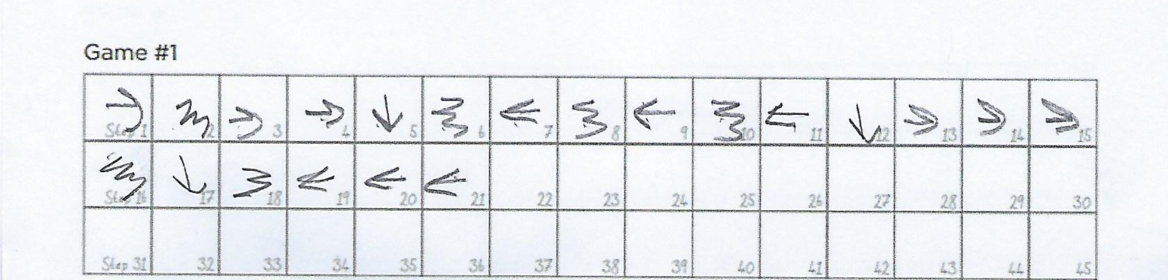

Xiaona Zhou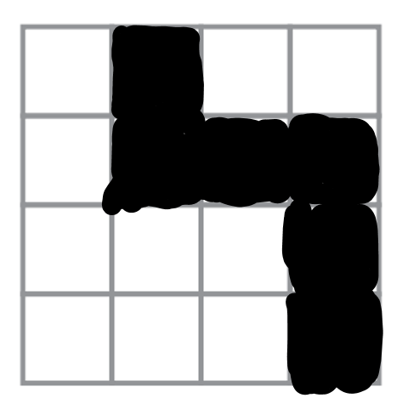

Vitoria (Program)

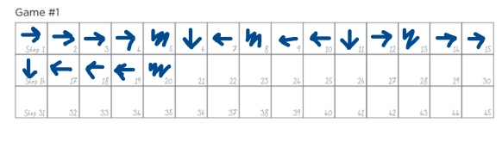

Ken B

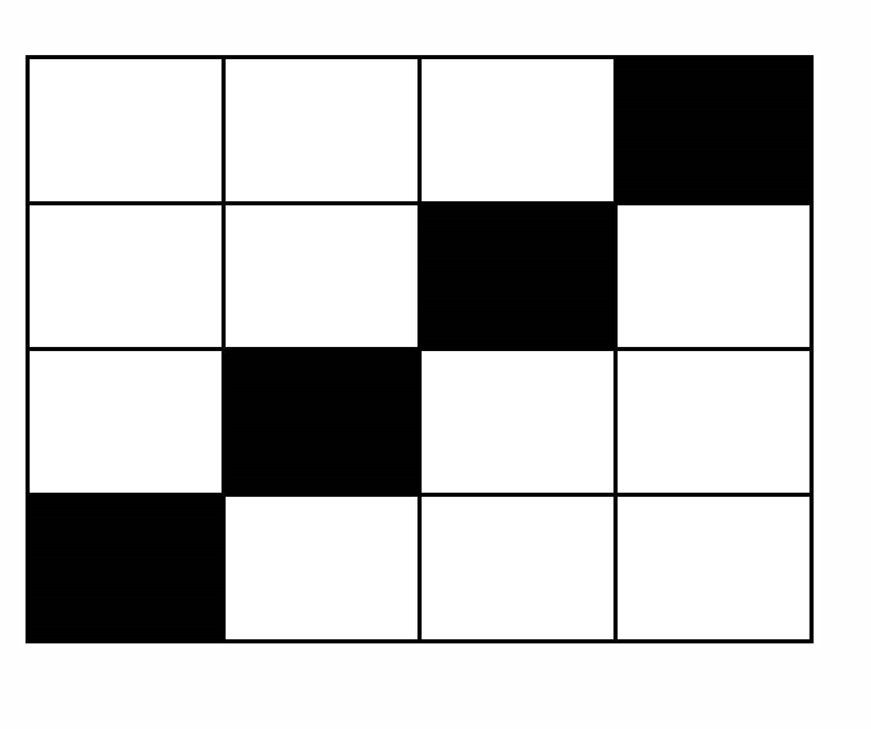

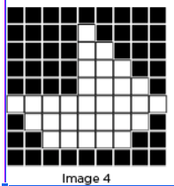

we should create functions for this one. it’s too complex.

def rc(x):

repeat go right, color x times

def lc(x):

repeat go left color x times

def gr(x): #go right x times

repeat go right x times

def gl(x): #go left x times

repeat go left x times

|  |  |  |  |  |  |  |  |  |  |  |  |
| --- | --- | --- | --- | --- | --- | --- | --- | --- | --- | --- | --- |
| color | rc(8) | go down | color and lc(3) | go left | lc(4) | go down | color and rc(3) | gr(3) | color and  rc(3) | go down | color |
| lc(1) | gl(3) | lc(4) | go down | color | rc(3) | gr(4) | rc(1) | go down | gl(8) | go down | color |

|  |  |  |  |  |  |  |  |
| --- | --- | --- | --- | --- | --- | --- | --- |
| gr(7) | rc(1) | go down | color | lc(1) | gl(5) | lc(2) | go down |
| color | rc(8) |  |  |  |  |  |  |

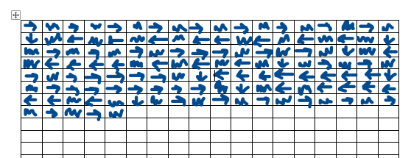(brute force version)

Tamzid









Vitoria

